1st Annual Westfield Garden Day
Plant & Seed Swap, Tree Giveaway, Family activities
May 19, 2018 10:30-1 p.m.
6009 Harford Road (Parking lot, Marzullo Funeral Chapel, Baltimore 21214)
Spring is in full Bloom! Join us for the 1st Annual Westfield Garden Day! Bring seeds and plants to swap with neighbors. Pick up a free tree for your yard with many thanks to TreeBaltimore! Learn about bird and butterfly gardening and native plants at our info table. Take part in fun family activities, including flower pot decorating, seed bomb making, and more!

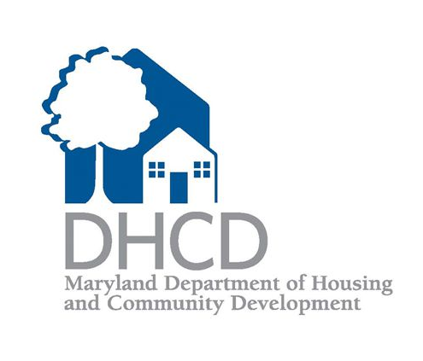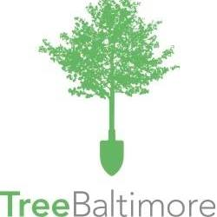
Questions? contact: Angela Jancius (urbanhomesteaders1@gmail.com), www.greeningwestfield.org

